**Java main() method**

The main () is the starting point for JVM to start execution of a Java program. Without the main() method, JVM will not execute the program.

The syntax of the main() method is:

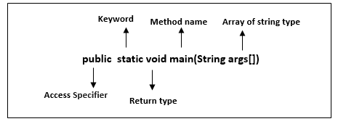

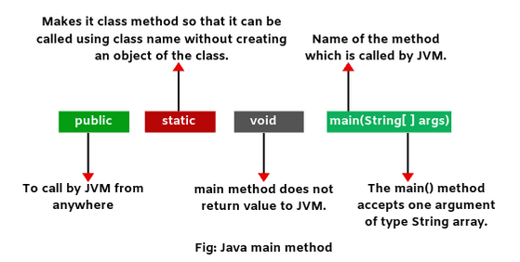

**public:**

It is an access specifier. We should use a public keyword before the main() method so that JVM can identify the execution point of the program. If we use private, protected, and default before the main() method, it will not be visible to JVM.

**static:**

You can make a method static by using the keyword static. We should call the main() method without creating an object. Static methods are the method which invokes without creating the objects, so we do not need any object to call the main() method.

**void:**

In Java, every method has the return type. Void keyword acknowledges the compiler that main() method does not return any value.

**main():**

 It is a default signature which is predefined in the JVM. It is called by JVM to execute a program line by line and end the execution after completion of this method. We can also overload the main() method.

**String args[]:**

The main() method also accepts some data from the user. It accepts a group of strings, which is called a string array. It is used to hold the command line arguments in the form of string values.

|  |
| --- |
| main(String args[]) |

Here, agrs[] is the array name, and it is of String type. It means that it can store a group of string. Remember, this array can also store a group of numbers but in the form of string only. Values passed to the main() method is called arguments. These arguments are stored into args[] array, so the name args[] is generally used for it.

## Overloading of main() method

We can also overload the main() method. We can define any number of main() method in the class, but the method signature must be different.

### Example

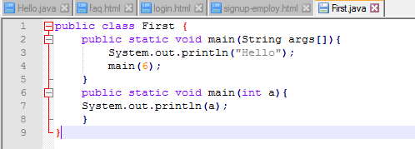

**Output:**

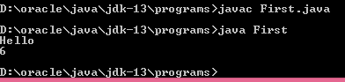

**Example for addition operation:**

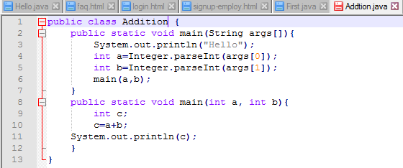

**Output:**

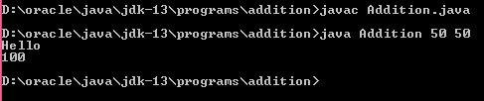

**FAQS:**

**What happens if the main() method is written in the program without (String[] args)?**

We will get the run time error as main method is not founded.

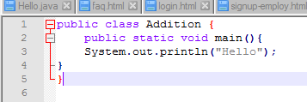

Output:

